|  |
| --- |
| IGATE |
| Resolution for Cartons with No Route in WMOS. |
|  |
|  |
| |  |  |  | | --- | --- | --- | | **Document Update** | **Updated By** | **Date** | | Created By | Sindhooja Seshadri | 3/14/2016 | | Reviewed By | Sabita Prasad | 3/29/2016 | | Reviewed By | Sabita Prasad | 6/06/2016 | |
|  |

|  |
| --- |
|  |

**Task name:** Resolution for Cartons with no Route in WMOS.

***Resolution for Cartons with no Route in WMOS issue.***

**Severity:** Medium

**Description:** Unable to add cartons to load in WMOS

**Issue:** User is Unable to add Carton to load as it is missing Route in WMOS.

**Identified:**

1. An email from the user or operations will report the issue with business process. The sample Case email attached here for reference.



**Mitigation approach:**

**Scenario 1:**

**Step 1**: Check the Carton details with carton number provided by the user in DB, by using below query.

Select count (*) from carton_hdr where carton_nbr ='00000197183464198317';

Alternatively check in WMOS UI:

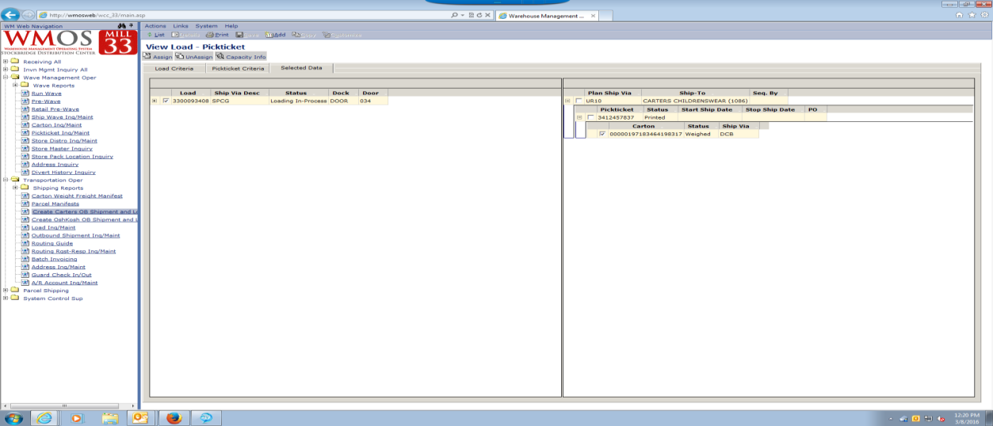

**Step 2:** Check if the carton has no route then Update the carton_hdr.rte_id in the carton_hdr table to ‘DFT’ by using the below Query.

Update carton_hdr

set rte_id = 'DFT',

user_id = 'RICKB',

mod_date_time = sysdate

where carton_nbr ='00000197183464198317';

**Below is the CCF:**

set echo on;

set heading off;

column date_column new_value filestamp

select to_char(sysdate,'YYYYMMDDHH24MISS') date_column from dual;

spool C:\ChangeControl\HDT160308_102334_33_&1..log

insert into setccf values ('CCF102334');

--102334

--CCF102334 -Change carton_hdr.rte_id to 'DFT'

select count(*) from &1..carton_hdr where carton_nbr ='00000197183464198317';

update &1..carton_hdr

set rte_id = 'DFT',

user_id = 'RICKB',

mod_date_time = sysdate

where carton_nbr ='00000197183464198317';

select count(*) from &1..carton_hdr where carton_nbr ='00000197183464198317';

insert into unsetccf values ('CCF102334'); Insert CCF#

show errors;

--spool off;

set echo off;

set heading on;